"Spirituality of the Evolving cosmos"
(Notes to a powerpoint presentation at a joint meeting of the British Teilhard Association and the Alister Hardy Society, 2005)

Chris Clarke

Title inspired by Teilhard, 40 years ago
I revisited The Phenomenon of Man. It had big influence on my early thought but it is startling today! - so much in science has changed since he completed it in manuscript in 1938 that were he to be writing it today it would need to be expressed in radically different ways
Two particular points

Cosmology
Quote from the phenomenon of Man: (257-8 1959ed)
“... modern man is obsessed by the need to depersonalise (or impersonalise) all that he most admires. There are two reasons for this tendency. The first is analysis ... The second reason lies in our discovery of the sidereal world, so vast that it seems to do away with all proportion between our own being and the dimensions of the cosmos around us.” – He gives a purely negative assessment of cosmology – that is no longer tenable.
Consciousness Studies
Consciousness (more generally interiority, Teilhard’s “radial energy”) not just a matter of function, of formal organisation, but involves an essential subjectivity - linking with spirituality (states of being rather than structures of becoming) This for me goes beyond Teilhard.
I think that because of these the spiritual message to us of the evolving earth has a different character than that which was seen by Teilhard over 60 years ago

Cosmology
Return to Teilhard’s quotation.- cf Pascal 1670 (Pensées) “The silence of those infinite spaces terrifies me”
Hubble's law 1929 (when T was in the process of writing Phenomenon) but Teilhard was probably still influenced by picture of a large scale structure that was stationary, with evolution taking place inside it (almost inconceivable today) Einstein changed course in 1931 to a fundamentally evolutionary view of the cosmos

Reminder of key points of cosmology (next slide) ...

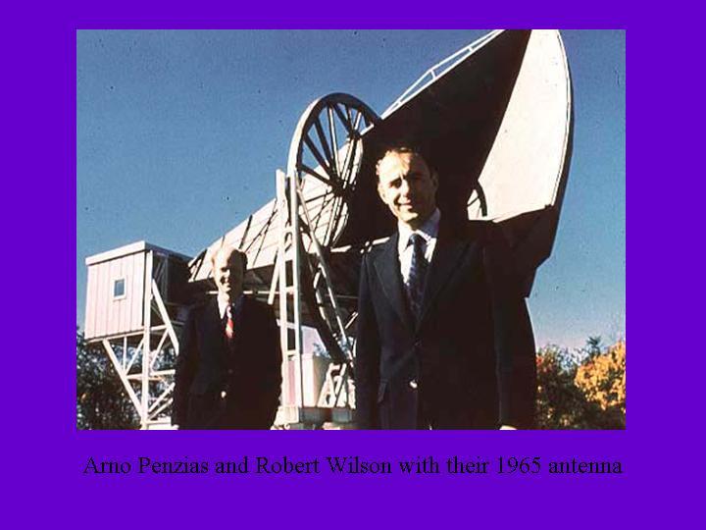

This illustrates the start of the second most important observation in the whole of cosmology. (The first most important was Hubble’s observation of the red-shift of distant galaxies, which showed that the universe was dynamically evolving as a whole, and not just cooling down.)
The slide shows Penzias and Wilson in front of the microwave receiver that detected the cosmic background radiation, a flux of radio waves reaching us with almost completely uniform intensity from all directions in the sky.
Subsequent work has shown that this radiation come from the very earliest stages of the universe, less than 400,000 years after the so-called big bang – a minute time compared to the 13,700,000,000 years that the universe has been in existence. It enables us to glimpse the very start of this cosmic evolutionary process.

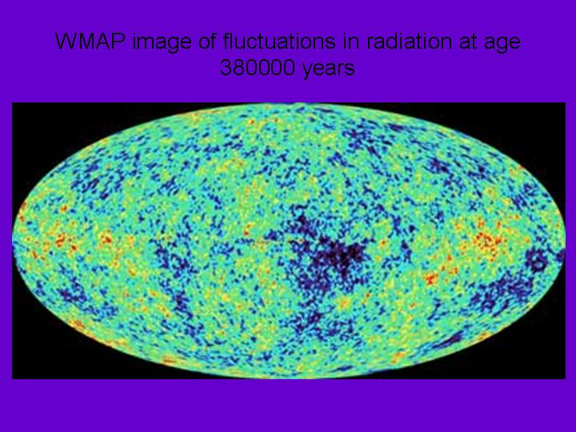

This is a representation of the most recent set of data from continuing observations of the background radiation. The radiation is now observed from a satellite, called WMAP (short for Wilkinson Microwave Anisotropy Probe), which is specially designed to detect the minute variations in the intensity of this radiation from one point to another. It is these variations, with a magnitude of no more than one part in 10000, that are depicted in the representation.
WMAP looks out in distance, and hence back in time, to a point before which the gas in the universe was opaque, the farthest back in time that we see using radio waves.
It shows that at this early stage the universe was an almost completely uniform cloud of gas, but marked by tiny fluctuations in density emerging from its earlier, hidden, history. The whole of the structure of the universe was to emerge from these fluctuations. Whereas Pascal saw “silence of infinite spaces”, which Teilhard viewed equally negatively, now we see a major part of the creative process that has brought the structure of the universe into being spread out before us – in many ways confirming the heart of Teilhard’s evolutionary vision, though he was unaware of it.

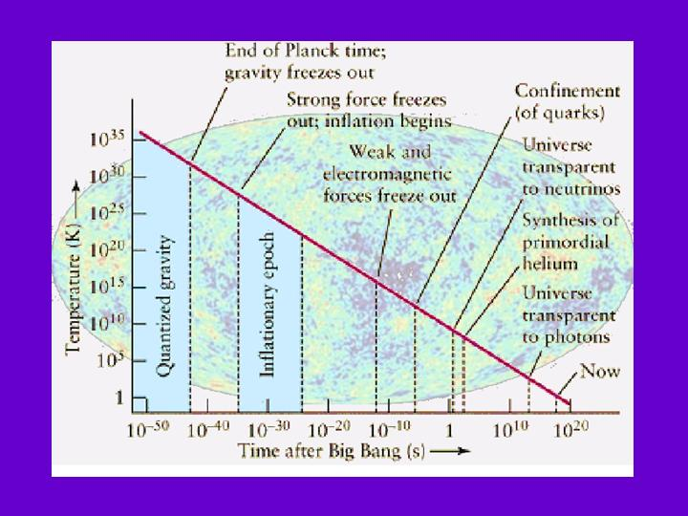

The remarkable thing about the WMAP pictures is that they confirm a story of the early universe which previously might have been seen as a rather wild extrapolation back in time of conventional physics. This slightly old slide depicts the main features. While the period before the inflationary epoch would be regarded by many as still speculative, WMAP gives us a lot of confidence in the subsequent history. It shows the ongoing creative processes involving not only the emergence of structure, but the emergence of the laws of physics themselves as the separate forces of electromagnetism and so on arise out of more primitive general forces. It gives another way of thinking about Sheldrake’s notion that laws are not eternal Platonic realities, but something more like habits.

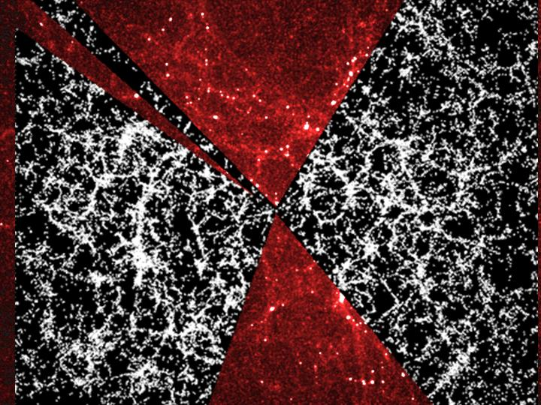
This [red part] shows the results of a computer simulation of how those initial variations form uniformity would have grown as the denser parts attracted more matter to themselves by gravity, forming a sponge-like structure of dense regions surrounding comparatively empty regions. And here [grey bit] is the corresponding observation of what the universe is in fact like now. This is a plot of a slice through the universe showing the positions of tens of thousands of galaxies.

In the following slides I have tried to give an impression of the way in which progressively more structure emerged from the earliest phase, at progressively finer length scales. First the fomation of stars, clustered into galaxies ...

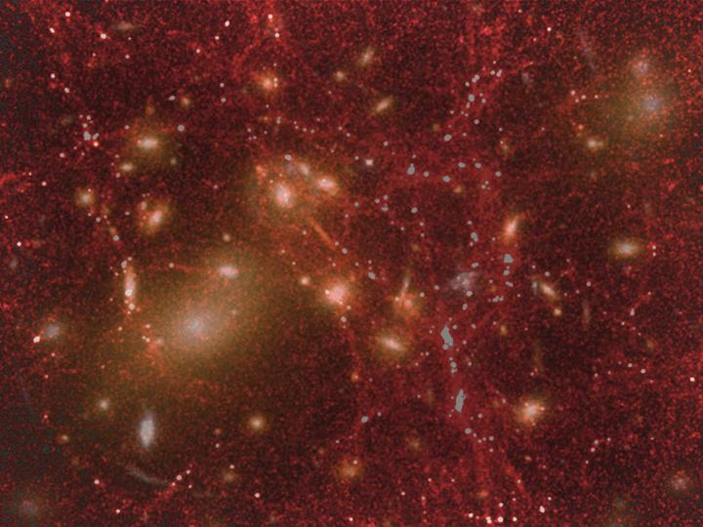

Then the interaction of galaxies with each other, forming spiral structure and triggering the evolution of stars

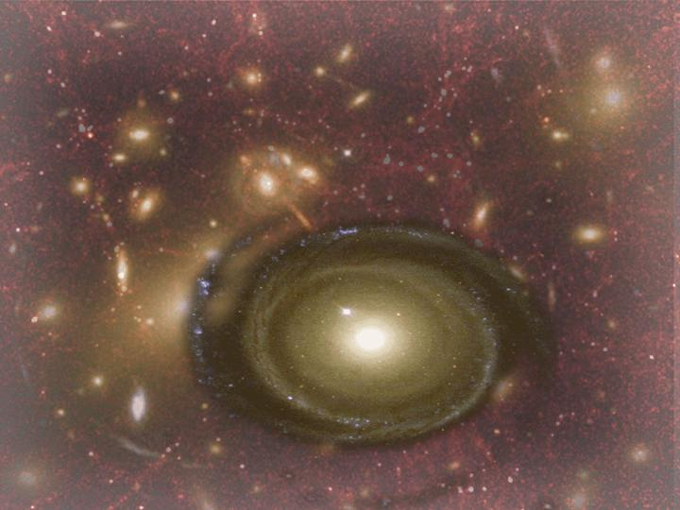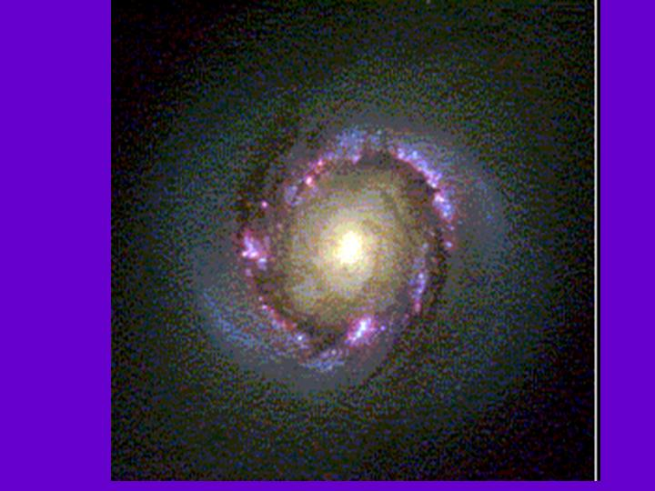
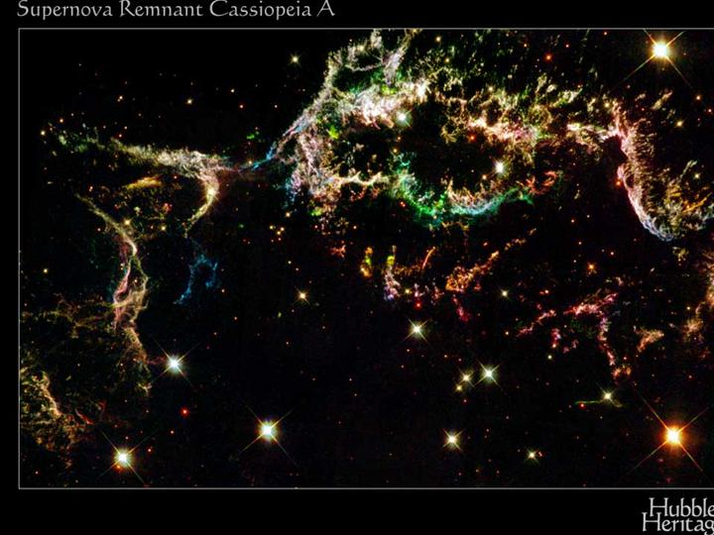

And then the death and explosion of stars, filling the galaxies with the heavy elements that were to form planetary systems

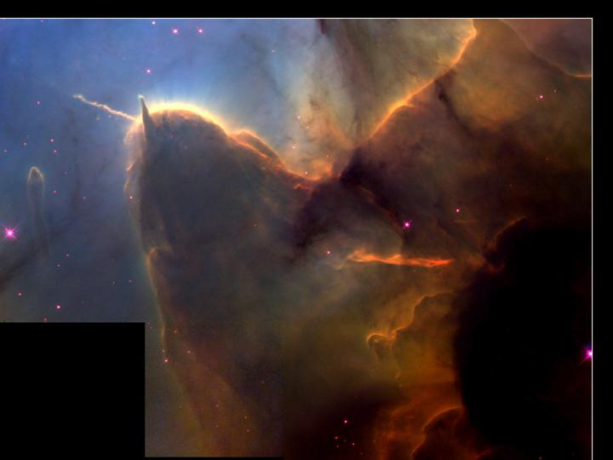

(A nursery of stars, some high velocity stars leaving the dust, trailing clouds of glory behind them)

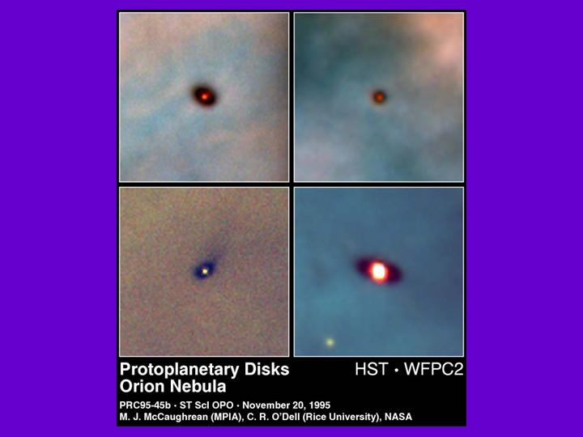

The birth of stars is accompanied by the birth of planets

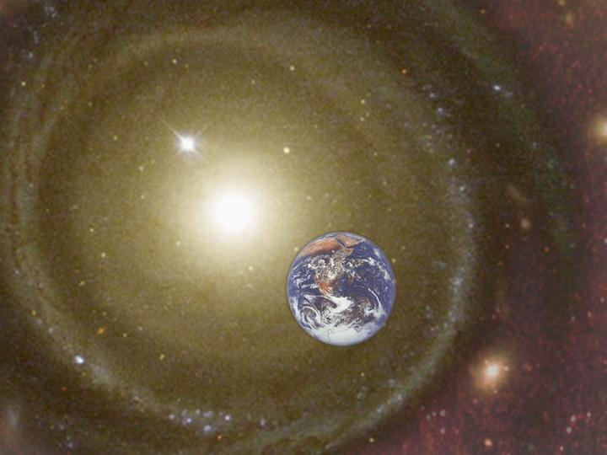

This saga extends Teilhard's vision to a vastly greater context
The distinctions between creation/evolution/creativity become a matter of degree
The cosmos becomes the ultimate material context, and source of fecundity, not only the earth

We now move on to the second area of science that alters and enlarges Teilhard's vision: Consciousness Studies
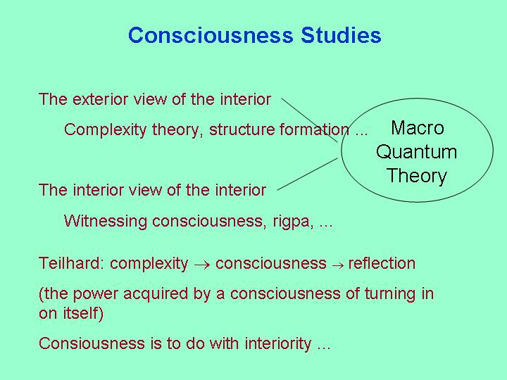

Teilhard talked of the growth of “complexity-consciousness”, and we have seen the complexity side of this in cosmology. But now I want to discuss the other new science unknown to Teilhard, Consciousness Studies.
Teilhard saw human consciousness as arising from a process in which complexity was coupled with “interiority” (or “radial energy”) – the germ of consciousness. This then was reflected on itself to form self-consciousness.
We now understand this process far more clearly as involving two interrelated ways of conceptualisation [click]. We can focus on the exterior view of the interior, which is mainly what Teilhard dealt with, or on the interior view of the interior, true self-reflection. The distinguishing of these is a major shift of viewpoint in the last 15 years or so, though its seeds go back to the first impact of Eastern thought on the West.
The exterior view of the interior
CLICK Complexity theory, structure formation ... (Bateson, Prigogine ...)
The interior view of the interior
CLICK Witnessing consciousness, rigpa, ... Role of Eastern thought (Western thought focused on content, rather than essence)
(Brunton - 1937, Secret of the golden flower – commentary by Jung in 1931) This was the first point where techniques emerged for distinguishing between the essence and content - the witness and that which is witnessed. And distinguishing between the witness and the relational object-self. Teilhard largely focused on the exterior view
The issue is, how are these two related? In particular, can the interior consciousness do anything?
I shall come back to this shortly. But first I want to make more speculative digression on how these two aspects are related, which I think is via what I call “Macro quantum theory”: not the theory of the very small, but using the language of quantum theory to apply to the whole world. Remarkably, the vision that makes this possible has come from our previous topic, cosmology. To recap an earlier slide ...

... cosmology now extends back to the earliest stage in which the universe had a minute size, at which stage one is forced to use quantum theory. So the discipline of quantum cosmology was born, a language that describes the entire sweep of the universe at all length scales in a unified way.
The point of taking this viewpoint in order to understand consciousness is that, irrespective of whether we are talking about the large or the small, the language of quantum theory explicitly brings the role of the observer into the picture, and so gives a more sophisticated analysis of the dimension of interiority.

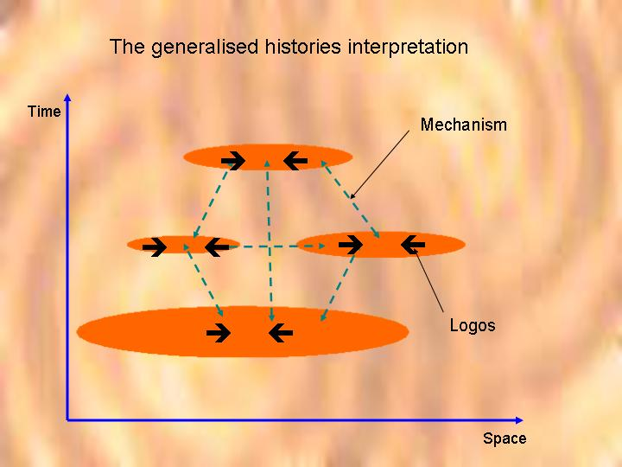

This slide illustrates the quantum cosmology (or “macro quantum theory”) viewpoint. In keeping with all modern cosmology, it takes a four-dimensional, space-time view, illustrated here by one dimension of space and one of time.
The most popular approach to quantum cosmology is then some version of the “histories interpretation”. A history is a collection of different manifestations at various places and times. I use the term “manifestation” rather than “observation” because modern quantum theory does not necessarily require the presence of a conscious observer, and one does not want to force the issue too soon as to whether consciousness is playing a role. The positions of a few of these manifestations are shown as the orange blobs in the slides. What the basic physics of quantum theory then does is to define a probability for the occurrence of any postulated history. The universe hangs together loosely: rather than the rigid connections of determinism, there are the weaker probabilistic links between events given by quantum physics and shown above by the blue dotted lines.
But there is more than this. As it stands the numbers given by quantum physics are not true probabilities, and they allow manifestations that are not in fact observed. An additional constraint is needed to restrict the sorts of manifestations that we can consider, a constraint on the mathematical logic that connects all the possible manifestations at a given place and time (black arrows). There is a very suggestive match here between the two aspects of complexity-consciousness: on the one hand there is mechanism, corresponding to the external view of the internal, and on the other hand there is what the physicist and philosopher Roland Omnès called logos corresponding to the internal view of the internal.

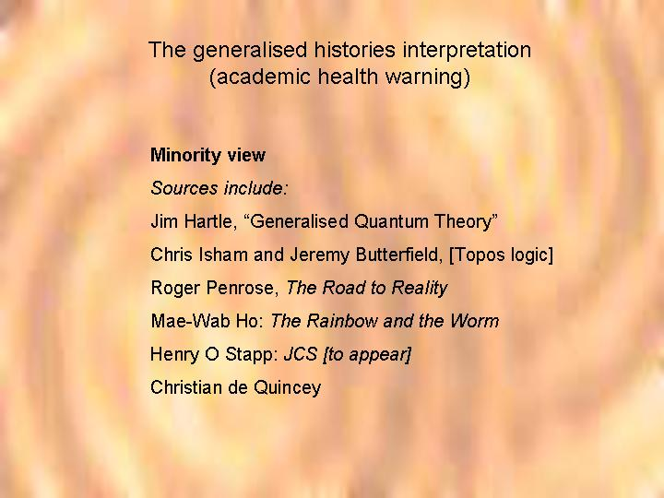

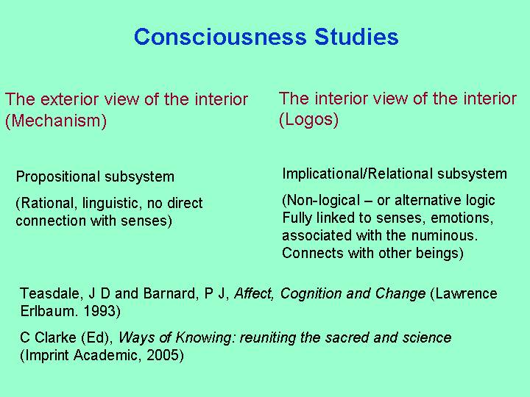

Now let’s return to the more usual human perspective, and see what modern experimental psychology can say about these two strands of interiority.
I’m going to suggest that they line up with the two cognitive subsystems that have been revealed as part of our information-processing systems by the Cambridge University Cognitive Science research group.
Teilhard had intimations of both columns of this slide, but by distinguishing them we can see much more clearly the structure of interiority

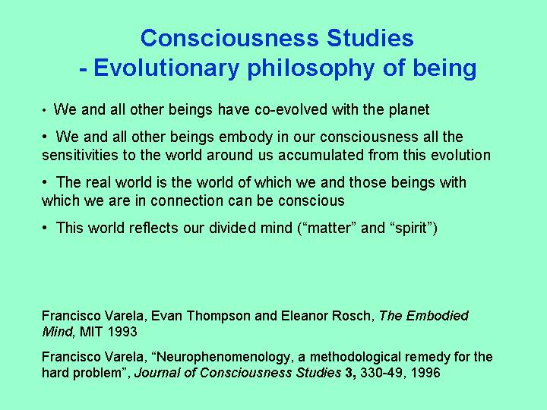

What does all this add up to? In broad terms, but with much more detail than was available to Teilhard, it gives us an evolutionary philosophy of being.

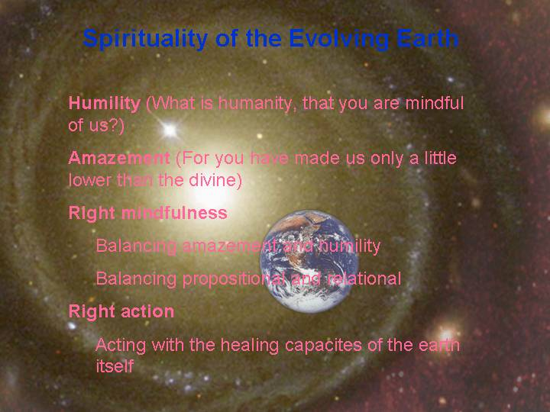

And finally ...
What do we get out of this vision of an evolving cosmos, in the spiritual terms that were Teilhard’s ultimate concern?
To describe spirituality, I would like to borrow two steps from the Buddhist "eightfold path" (in common with the paths of many other faiths) - Right mindfulness and Right Action
Right mindfulness on an evolving planet means restoring the connections with the planet to which we are heirs -
becoming aware of our interconnections with other beings, sharing at the both intellectual and relational level with the sensitivities that link us with the world, in all its dimensions
This awareness then brings revelation ...
Humility (what is man that you are mindful of him?)
Humanity is no longer at the centre
Awe and amazement
(You have made man a little lower than the angels)
Right action
Responsibility - grasping the thread of evolution in a balance of awe of humility
Acting with a balance of the two modes of being, internal/external, propositional/relational letting go of the illusion of control, acting with the healing capacities of the organism that is the earth

